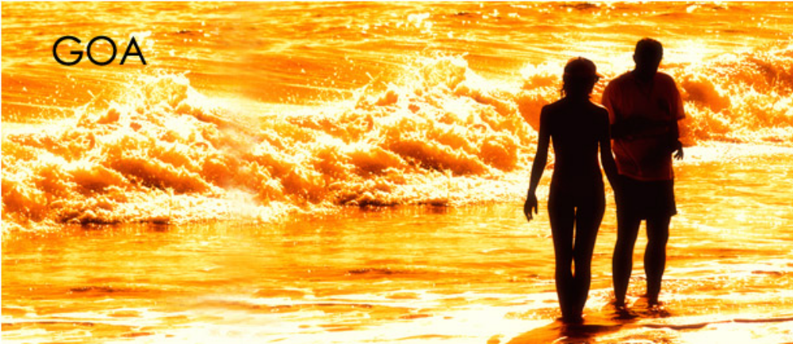
Goa known to many as "Pearl of the Orient" or the "Tourist Paradise", has a lot to offer, the tropical climate, the coconut trees, the white sand beaches. It is now the No 1 tourist destination for Indians who want to just relax.

North Goa

Aldeia Santa Reita, Goa

starting from Rs.3,150*
Built in the style of a Portuguese village, Aldeia Santa Rita provides a delightful escape with its multi-hued, well-manicured appeal. A swimming pool with sun lounges, spacious rooms....

Whispering Palms Beach Resort, Goa

starting from Rs.3,188*
Ensconced between Aguada foothills & a tiny hamlet Candolim lies this boutique beach resort "Whispering Palms-Goa" set up in the year 1992, offering a blend of Portuguese heritage & contemporary comfort....

Marquis Beach Resort, Goa

starting from Rs.3,325*
Marquis Beach Resort is set on four acres of landscaped garden situated on the beautiful Sinquirim beach. This 29 room holiday beach resort has an excellent location on the North Coast where you are just....

Ronil Beach Resorts, Goa

starting from Rs.3,325*
The gateway you wont able to get away from, a paradise, where the days are made of brilliant sunshine frolicking waves and golden sands knocking on your window. The nights of heady fun, festivity and....

Hotel Goan Heritage Beach Resort, Goa
starting from Rs.3,410*
Hotel Goan Heritage is located along the beach, and is ideal for a pleasurable holiday. If you are seeking genuine Goan hospitality, then look no further. The resort is situated in the middle of the 9 km long, golden sand, Calangute beach....

Bambolim Beach Resort, Goa

starting from Rs.3,825*
Bambolim Beach Resort started in 1989. As a 57 room resort set in six cottage blocks with rooms done up in a rustic style. Now expanded to 126 rooms with the addition of the new 69 rooms main block with highly....

Angels Resort, Goa
starting from Rs.4,000*
Angels Resort is located in the heart of Porvorim. 12 kms from Tivim railway station, 39 kms from Margao railway station and 40 kms from Dabolim Airport. It is 5 kms from Calangute beach and 3 kms away from Panaji....

Victor Exotica Beach Resort, Goa

starting from Rs.4,040*
Victor Exotica Beach Resort, located in the heart of the tourism belt of North Goa. Victor Exotica Beach Resort is just the place you would want to be spending your vacation....

Hotel Paradise Village, Goa

starting from Rs.4,400*
An oasis of comfort and tranquility, the Village encompasses a myriad of luxurious facilities for your pleasure. Paradise Village is situated on Calangute beach, &quot;The queen of all beaches & quot; in Goa..

Sonesta Inn, Goa
starting from Rs.4,465*
Enjoy a perfect beach side location on the beautiful stretch of Candolim's Golden Sands, an ideal place to relax. Tastefully arranged around a vast central pool area, a gently shelving expanse of sand and garden....

The Majestic, Goa

starting from Rs.4,500*
The Majestic is a Business/Leisure 5 Star hotel located at Porvorim Village, North Goa among the lush green background opposite the river Mandovi, just 4 minutes from the Capital city of Goa, Panaji, 30 minutes from....

Taj Holiday Village, Goa

starting from Rs. 5,050*
The perfect combination of modern elegance and timeless hospitality, this complex of terracotta-roofed cottages takes its inspiration from Portuguese-Goan design....

Taj Fort Aguada Beach Resort, Goa

starting from Rs. 5,100*
Built on the ramparts of a 16th century Portuguese fortress, this resort is part of a sprawling 88-acre complex overlooking the Arabian Sea. Situated in close proximity to the beach, Fort Aguada Beach....

South Goa

Heritage Village Club, Goa

starting from Rs.2,975*
Heritage Village Club, South Goa offers luxurious accomodation. Choose from the chic design room, the Desgin Room and Two Suites. Or opt for our wonderful suites. All rooms come with a view Put garden or poolview....

The Kenilworth Beach Resort & Spa, Goa
starting from Rs.3,200*
The Kenilworth Beach Resort & Spa, Goa, is the epitome of true Goan hospitality combined with international club facilities; you would get a holiday experience of a lifetime. Fresh water pools or the vast....

The Oceanique Resort, Goa

starting from Rs.3,825*
The Oceanique Resort offers great value in an intimate setting, the advantage of proximity to some of goa's most stunning beaches and tourist attraction, with peace and tranquility beckoning you back.....

Varca Palms Beach Resort

starting from Rs.4,275*
Varca Palms Beach Resort, Goa is located on one of the most magnificent beaches in Goa with 27 kilometers of golden sand. It is just 45 minutes from the Dabolim airport and within reach of every major tourist attraction....

The Leela, Goa

starting from Rs. 5,948
The Leela Goa, a 5-star beach resort, is a contemporary celebration of south India's Vijayanagara Empire temple and palace architecture, and Goa's Portuguese heritage. Tucked away in the South Goa...

Dona Sylvia Resort, Goa

starting from Rs.5,950*
The Dona Sylvia is a Mediterranean Style Club Resort. Located in the heart of the tourism belt, spread over 26 acres of landscaped gardens along the stunning Cavelossim Beach in South Goa....

Clarion The Beach, Goa

starting from Rs.6,375*
Luxurious and distinctive, Clarion Hotels, Suites and Resorts offer that special class found only at the world's best hotels. Upscale amenities and flawless attention to detail combine to create the Clarion experience....

Majorda Beach Resort

starting from Rs.6,499*
The hotel is situated on a 26 km stretch of soft white sand in South Goa. It is 15 minutes from Dabolim International Airport and 10 minutes from Margao Konkan Railway Station....

Taj Exotica Beach Resort, Goa

starting from Rs.6,750*
Located on the southwest coast of Goa, overlooking the Arabian sea, this Mediterranean-style resort has a way of slowing down time to a tranquil tempo. Set amidst fifty-six acres of lush gardens....

Holiday Inn Resort, Goa

starting from Rs.6,999*
The Holiday Inn Resort Goa, a Five Star Resort is located on the Mobor beach, in the South of Goa. All 187 luxuriously appointed rooms and suites overlook the Arabian Sea and are...

Radisson, White Sands Resort, Goa

starting from Rs.7,499*
The Radisson White Sands Resort, Goa is also known for its state-of-the art fitness center, luxury full-service health spa and Water Sports Centre. With a prime Goa location on one of the world's longest...

Park Hyatt Goa Resort and Spa

starting from Rs 9,750*
Breathtaking views of a sparkling lagoon and manicured lawns welcome you to a 41-sq.-metre room reflecting Goa's rich cultural heritage, including contemporary artwork, one king or two twin beds and open-plan...

